How to use Driver Talent Tool Fix driver issue?

Introduction: This is a easiest way to make sure the USB card, Wireless Card etc work on PCs. The tool will fix driver issues or help user complete driver installation. For example when users find their USB card ,Wireless Network Card ,Bluetooth, Printer etc can’t work or Windows can’t provide driver automatically. Use Driver Talent scan PCs, It will search useful drivers for your device online.

**NOTE: Please ensure PC have internet connection when using Driver Tool.**

Step 1, Put mini CD in and open the file folder, find the folder named as Driver Tool .

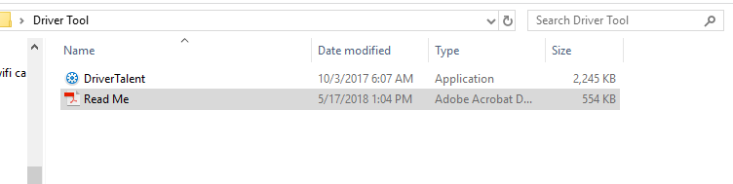

Step2. Double left-click Driver Talent Application, Users will got a message from Windows left-click “Yes”

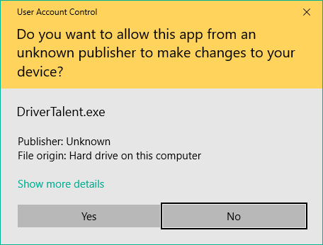

Step 3,Users will find this page on their PC, Left-Click “Scan”, This tool will find which device need to install driver which device need to update driver. Select the correct device install the driver. It will download and install on PCs automatically.

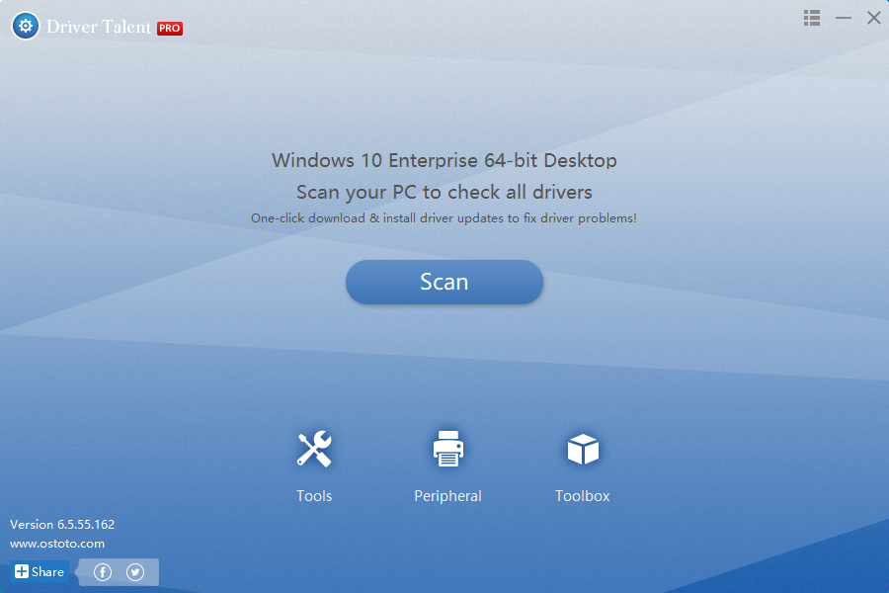

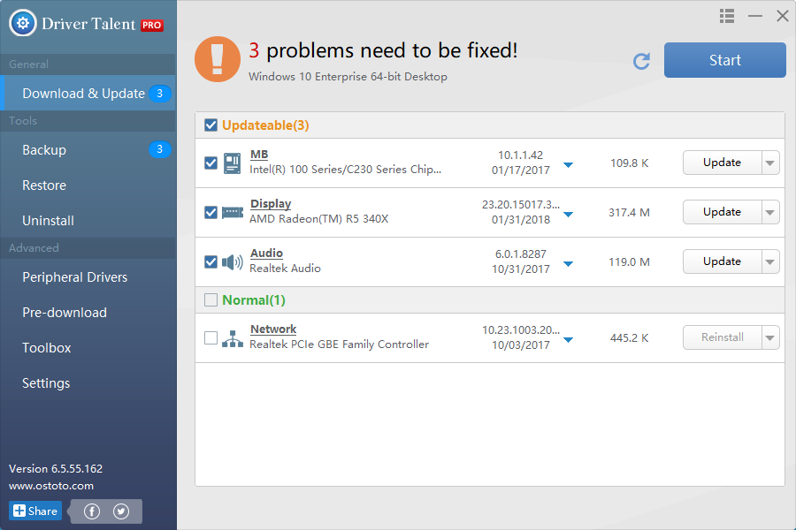

**How to remove Driver Talent from PC?**

**Follow Operate:** Control Panel –Program-Uninstall a program-Find driver talent and remove

**Who is Driver Talent?**

Driver Talent Tools will help users Download the best-matched drivers, Update to the latest drivers, Fix driver issues, Install drivers for computer hardware or USB-connected devices.

**NOTE:** This tool copy rights belongs Driver Talent: <https://www.drivethelife.com/>

Users can download new version from driver talent site.

We suggest users try free version.

Thanks for Your Time